A347-Eur-Crete-Gourniá-Female Figurine-Faience-1350-1200 BCE

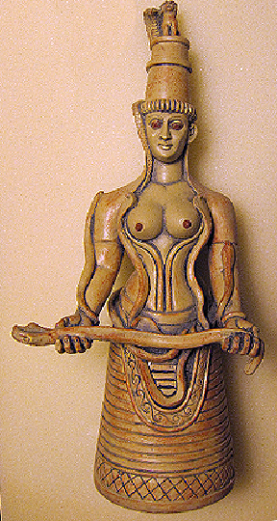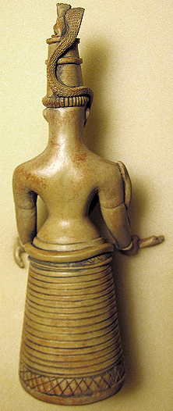

Figs. 1-2. Crete-Gourniá-Female Figurine-Faience-1350-1200 BCE

**Case No.: 4**

**Accession Number: A347**

**Formal Label:** Crete-Gourniá-Female Figurine-Faience-1350-1200 BCE

**Display Description:**

Gourniá on the north coast of the Isthmus of Ierapetra in East Crete is a Late Bronze Age (1350-1200 BCE) town with 50 well-preserved houses, cobbled streets from the coast to the town center, a central court, a Minoan palace, a shrine to the Minoan goddess, and a cemetery. Gourniá produced bronze tools and weapons, domestic objects, and pottery and stone vases. It was engaged in trade with other areas of the Aegean and the Near East. Its harbor consisted of a ship shed, fortification walls with bastion towers and a riverside dam. The American archaeologist Harriet Boyd first excavated the town in 1901–1904, when she excavated a faience female figurine with a snake wrapped around her body, right shoulder, and arms in a shrine, dating to 1350-1200 BCE.

**LC Classification** DF221.C8

**Date or Time Horizon:** 1350-1200 BCE

**Geographical Area:** shrine at Gournià, Crete

**Map,**

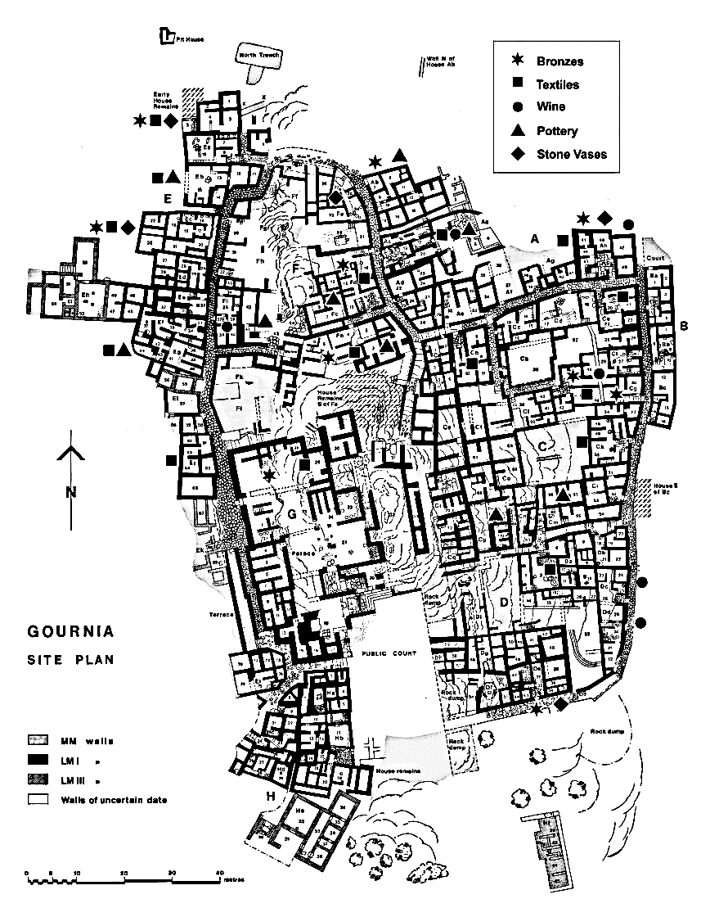

Late Minoan I Town of Gournia by K. Iao (after A. Heimroth (Watrous et al. 2012)). http://www.gournia.org/resources/Tour%208%20new%20resized.jpg.opt857x1120o0%2C0s857x1120.jpg

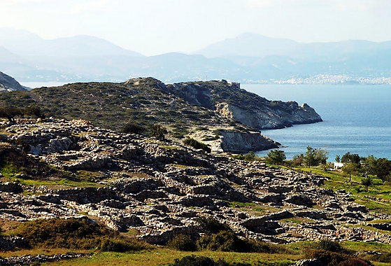

Shrine at Gournià, Crete<https://pbs.twimg.com/media/CKLrp4gUwAAzevw.jpg>

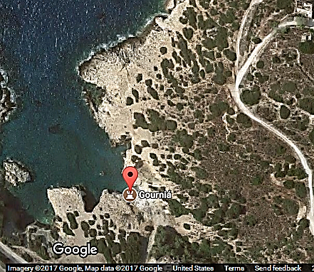 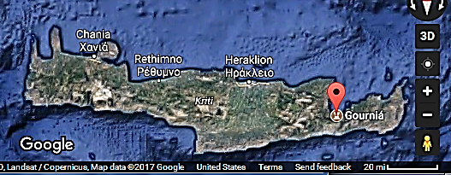

**GPS Coordinates:** 35°06'19.80" N 25°47'19.79" E

**Cultural Affiliation:** Minoan

**Geographical Area: Gournia, Crete**

**Medium:** Faience

**Dimensions**: H 34.2 cm, 131/2 in  
**Weight: n/a**

**Provenance:** (Archaeological Museum, Herakleion)

**Condition:** replica

**Discussion:**

She wears a tall purplish-brown headdress with a white border. She stands with her arms extended in front with the palms up.

In her right hand she grasps the head of a long greenish snake spotted with purple-brown the body of which winds up the upturned flat underside of her forearm, over her right shoulder, down one side of her back, over her buttocks, up the other side, over her left shoulder, and down her right arm.

A second snake has its tail looped over her right ear and extends down over her right shoulder following the curve of her exposed breast down below her waist, then loops back up the left side of her torso, up in front of her left ear, and up her tall headdress. A third snake encircles her waist, its body forming a knot in the front. Evans describes the general ground color, including the flesh tint, as being of milky white, with the various details in purple, purplish-brown, or black.

The figurine has been reconstructed from many pieces. Of the original figurine, only her torso, right arm, head, and her headdress (except for a portion at the top) were found. It not at all clear, for example, that it is one single snake that has its head in her right hand and its tail in her left.

**References:**